TYPES OF BONDING

All chemical reactions involve electrons from the reactants interacting with each other to produce more stable electron configurations. In most instances, after elements have reacted, each of the atoms within the molecule has achieved the electron configurations of the noble or inert gases.

The inert gases of Group VIII are very stable due to their filled valence shells. All elements would like to obtain the same electron configuration when bonding - such an arrangement is called a Stable Octet.

Octet Rule: most elements attain an octet configuration when they bond.

In most cases this means that after reacting, the atoms have eight electrons in their outer shell.

Hydrogen is an important exception to the octet rule, as it achieves only a maximum of two electrons, which is the noble gas configuration of helium.

The two ways in which atoms can achieve noble gas configurations are by:

• sharing electrons between atoms (covalent bonds).

• transferring electrons between atoms (ionic bonds).

Ionic Bond

Ionic Bond: the electrostatic attraction between oppositely charged ions.

Generally, all metals plus the ammonium ion NH₄1+ form ionic bonds with non-metals from the right hand side of the periodic table.
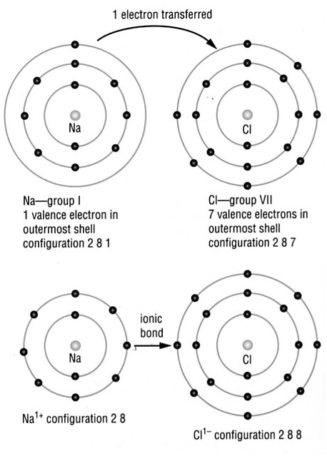
e.g. Consider the formation of NaCl.

• Na is in Group I and will donate 1 electron.
It will now have the same electron
configuration as the nearest inert gas Ne.
It will form Na¹⁺ ion.

• Cl is in Group VII and has room for one
electron to fill its valence shell like the
nearest inert gas Ar. It will form Cl¹⁻ ion.

This process is described by electron dot diagrams, which are used to represent the electrons in the valence shell.

e.g. Na • represents a sodium atom with one electron in its valence shell.

[Na]1+ represents a sodium ion formed when the one electron is donated from the
valence shell.
Cl
1-
represents a chlorine ion with a donated electron to fill the valence shell.

1 donated electron gives a -1 charge on the ion.

Note Square brackets [ ] are used for ionic substances.

Other Examples

• Al2O3 - show the number of ions involved.
2 [Al]3+ + 3

• Draw the electron dot diagrams for the following ions.

MgCl₂ CaO

KBr AlF₃

Covalent Bond

Covalent Bond: mutual electrostatic attraction for a shared pair of electrons by two
adjacent nuclei.

Generally, covalent bonds form between :

• hydrogen and non-metal elements on the right hand side of the Periodic Table.

• non-metal elements on the right hand side of the Periodic Table.

It is also possible to have double or triple covalent bonds where two or three pairs of electrons are shared.

e.g. Fluorine molecule F₂.

• By sharing one electron from another F atom, both F atoms have the same
electron configuration as the nearest inert gas Ne.

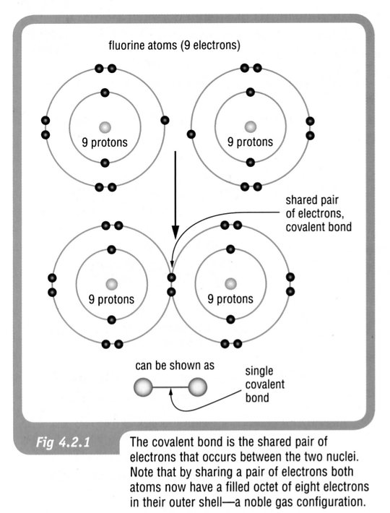

e.g. Oxygen gas O₂ Nitrogen gas N₂
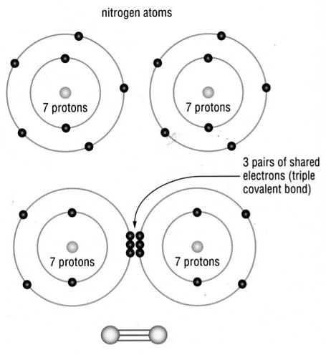
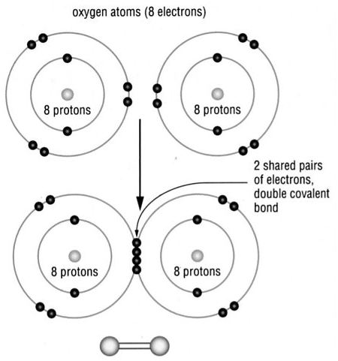

Note For covalent substances no square brackets [ ] are used in electron dot diagrams.

F
F
O
O
x
x
x

e.g. Single bond Double bond
ELECTRONS ARE
SHARED
, NOT
DONATED.

x
N
N
x
x
x
x
Triple bond

Other examples
O
x
H
H
O
C
O
x
x
x
x
• Water • Carbon dioxide

• Draw electron dot diagrams for the following covalent substances.

HCl PF₃

H₂S CH₃Cl

Metallic Bond

Metallic Bond: due to the electrostatic attraction between delocalised electrons and
the positive metallic ions.

In metals, the positive ions are in fixed positions while the delocalised electrons are free to move amongst them.

It is the electrostatic attraction of all the positive ions for the electrons that holds the lattice together.

